 | School of Computing  FIRST CIA Test – Aug 2025  Course Code: INT317  Course Name: DATA MINING AND ANALYTICS  Duration: 90 minutes Max Marks: 50
PART - A
Answer All the Questions 5X10 =50 Marks
1. A dataset contains two features X₁ and X₂​, recorded for four entities:
Features | E₁ | E₂ | E₃ | E₄
X₁ | 2 | 3 | 4 | 5
X₂ | 4 | 6 | 8 | 10
Perform a Principal Component Analysis to reduce the dataset from two dimensions to one dimension.
1)Mean(X₁) = 3.5: Mean(X₂) = 7 (1 Mark)
2)Covariance Matrix (2 Marks) 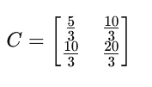
3)Normalized eigen vector (3 Marks)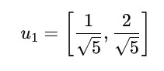
4)New Dataset (3 Marks)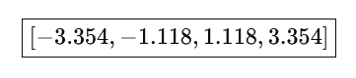
5)Plotting the coordinate system (1 Mark)

2. A database has 10 transactions with min_support=40% and min_confidence=70%
TID | Items Purchased
T1 | {Milk, Bread, Eggs}
T2 | {Milk, Bread, Butter}
T3 | {Bread, Butter, Jam}
T4 | {Milk, Bread, Butter, Eggs}
T5 | {Bread, Butter}
T6 | {Milk, Eggs}
T7 | {Milk, Bread, Butter, Jam}
T8 | {Bread, Butter, Eggs}
T9 | {Milk, Bread, Jam}
T10 | {Bread, Butter, Eggs, Jam}
- Find all frequent itemset using Apriori Algorithm (5 Marks)
Itemset | Support Count
{Milk, Bread} | 5
{Bread, Eggs} | 4
{Bread, Butter} | 6
{Bread, Jam} | 4
- List all the strong association rules (5 Marks)

- Milk → Bread (conf = 83.33%)
- Eggs → Bread (conf = 80%)
- Bread → Butter (conf = 75%)
- Butter → Bread (conf = 100%)
- Jam → Bread (conf = 100%)

3. Generate the frequent pattern from the following data set using FP growth, where minimum support = 3.

TID | Items Bought
100 | f, a, c, d, g, i, m, p
200 | a, b, c, f, l, m, o
300 | b, f, h, j, o
400 | b, c, k, s, p
500 | a, f, c, e, l, p, m, n

FP Tree Construction (5 marks)

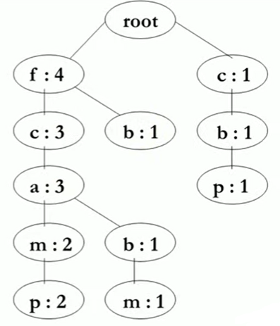

Frequent Patterns Generation (5 Marks)

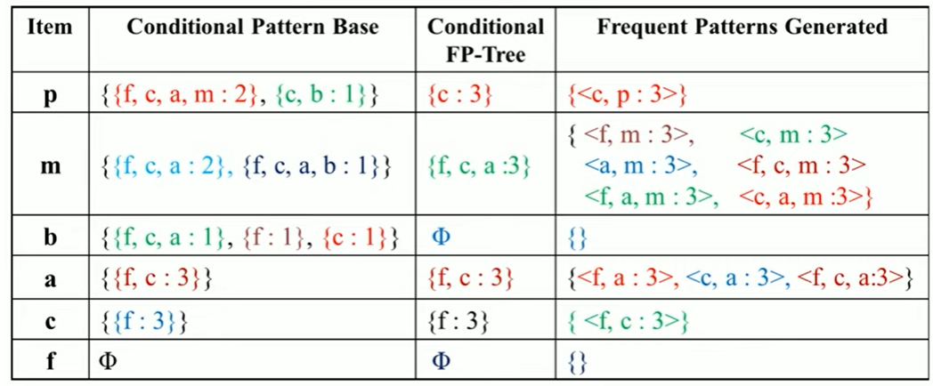

4. (i)The dataset below shows three numerical attributes for 5 products:

Product | Weight (kg) | Price ($) | Rating (1–5)
P1 | 5 | 500 | 4.5
P2 | 12 | 1500 | 3.8
P3 | 8 | 1000 | 4.2
P4 | 20 | 3000 | 2.5
P5 | 15 | 2000 | 3

a)Apply Min–Max normalization to transform the Weight value 20 in the range [0.2, 0.8]. (2 Marks)
Normalized Weight (20) = 0.8
b) Apply Z-score normalization to transform the Price value 1000.
(3 Marks)
Mean=1600, standard deviation=860.23
Z-score normalized Price (1000) ≈ -0.697

ii) Explain the steps involved in KDD Process (5 Marks)
- Data Selection
- Data Preprocessing
- Data Transformation
- Data Mining
- Pattern Evaluation
- Knowledge Representation
5. You are provided with a dataset of patient medical records that contains missing values, duplicate records, and noisy data. Explain the preprocessing steps you would implement to prepare the dataset for predictive modeling.

Data Cleaning
- Handle missing values:
  - Numerical features → Mean, median, or regression-based imputation.
  - Categorical features → Mode or predictive imputation
- Remove duplicates:
- Noise Reduction
  - For numerical attributes: Apply smoothing techniques (e.g., moving average, binning) or detect outliers using statistical methods (Z-score, IQR).
  - For categorical attributes: Correct inconsistent category labels (e.g., “M” vs. “Male”).
- Data Transformation
  - Normalization or Standardization:
  - Encoding categorical variables:
- Data Integration & Consistency Check

